Classifying URLs

A Machine Learning Approach

Springboard Data Science Program

Capstone II Project - Final Report

Author: Helga Wilde

Executive Summary 3

Background 3

Identifying Malicious URL Content 3

Machine Learning Techniques 3

Project Goals 4

Project Approach 4

Classification Model 4

Feature Set 4

Data Sources 4

Data Wrangling 5

Feature Creation – Feature Set 1 5

Feature Set 1 - Final Data Wrangling Steps 7

Feature Creation – Feature Set 2 7

Exploratory Data Analysis 7

Url String Analysis 7

Registered Domain Analysis 8

Netloc String Analysis 9

Path String Analysis 9

Inferential Statistics 10

Machine Learning 10

Model Evaluation Metrics 10

Feature Set 1 Machine Learning Model 11

Feature Set 2 Machine Learning Model 17

Machine Learning Summary 21

Using a Model in a Production Environment 21

Next Steps 22

# Executive Summary

Malicious web content is leveraged by threat actors in phishing and malware attacks. This web content may assist an actor in achieving objectives such as credential harvesting, data exfiltration, or data destruction. Threat actors have utilized their own web-based infrastructure in phishing and malware attacks, but they also compromise legitimate, reputable websites to host their malicious content.

It is imperative to detect and block malicious urls effectively, and organizations utilize a host of preventive and defensive measures to block these and other threats. Machine learning techniques are being applied to cyber security problems, and there have been several studies which employ machine learning algorithms to classify urls. These studies have leveraged a variety of predictor features to train their models. This project differs, as it attempts to build a light-weight predictive model that leverages url strings as the basis for its feature set. Models are trained on two select feature sets, one based on url lexical features and another base on TF-IDF scores, a natural language processing scoring technique applied to url segments, or ‘tokens’. This report shows that while both approaches are at least 90% accurate in classifying urls, models trained with TF-IDF-based features achieve superior results.

# Background

## Identifying Malicious URL Content

How do users determine if a url presented in/on email, text, social media or a website is safe? Users typically rely on the security industry’s systems and software to protect them from making an uninformed choice.

For the security industry, protections against malicious urls has historically been based on:

1. Reputation checks on the url and/or its underlying domain infrastructure

2. Analysis of the underlying web resource

* Connection and evaluation of the web page's source code
* Evaluation of the communication between web client and web server
* Heuristic analysis of the follow-on activity on the client system

Ongoing url analysis can and does support a multitude of detection and prevention-based security tools, either by identifying the integrity of specific domains and urls, or by providing details on specific malicious tactics, techniques and procedures (TTPs) used by threat actors.

## Machine Learning Techniques

Machine learning techniques are being applied to cyber security problems, and several machine learning models have been built to classify urls. These studies utilize one or more of the following sources to develop data feature sets used to train and test new models:

1. The URL itself. Lexical, aka textual properties, of the URL link.
2. Host-based characteristics
   1. Reputation lists for url, domain and/or hosting IP address.
   2. Domain name registration information. WHOIS properties such as name servers, associated IP addresses, registrant and registrar records, and dates like domain creation, update and expiration.
   3. Domain name resolution information. DNS records pertaining to the hosting infrastructure, including A, MX, NS, PTR records, IP addresses across all records. Geographic location may be utilized as well.
   4. Connection speed to/from web client and host
   5. Link popularity. A measure of traffic to/from url resource as compared to established, benign web resources.
   6. URL resource code. Assessment of web content such as links, tags, scripts.

# Project Goals

The goal of this project is to build a feature set and machine learning model that:

* Accurately classifies a url as benign, phishing or malicious
* Is self-reliant and not dependent on url reputation data, domain registration, DNS information, or connection to a url link.
* Is not limited or compromised by a threat actor’s anti-forensic techniques.
* May be incorporated into an existing security operations and automation tool, to quickly classify a url that has made it past preventive security measures.

# Project Approach

## Classification Model

This project’s goal is to build one multiclass classification model and accurately classify a url as benign, phishing or malicious.

## Feature Set

With the above goals in mind, this project will attempt to focus solely on a url’s lexical features to build a safe, efficient machine learning model.

Two approaches will be used. The first approach is to build out a large feature set based on the url string and url components (such as domain name, path, etc.). This is Feature Set 1.

The second approach is to rely solely on a feature set of url tokens and use natural language processing techniques on these tokens prior to model training and testing. This is referenced as Feature Set 2.

# Data Sources

Phishing URLs - Over 17,000 phishing url links were retrieved from PhishTank[1]. PhishTank is a collaborative clearing house for data and information about phishing on the Web. It's url lists are available to developers for integration into tools and applications.

Malicious URLs – Over 600,000 malicious url links were retrieved from abuse.ch[2]. Abuse.ch operates the URLHAUS project, which collects and shares malware URLs to assist network administrators and security analysts in protecting their networks from cyber threats.

Benign URLs - Over 25,000 urls were collected by crawling Alexa's list of the top 2500 websites[3]. Internal and external links were captured. In order to validate that each url was 'benign', each url's reputation was checked via Virus Total’s reputation service[4]. VirusTotal inspects urls with over 70 antivirus scanners and URL/domain blacklisting services, as well as other tools. Virus scans were requested in those instances where a url had no previous scans or reporting available.

Final Dataset – A random sample of 10,000 benign, phishing and malicious urls were taken for a total of 30,000 records for exploratory data and statistical analysis, and machine learning.

# Data Wrangling

URL records were merged together, each record consisting of a url and corresponding category.

## Feature Creation – Feature Set 1

Six new features were created by parsing the url into scheme, netloc, path, params, query, fragment.

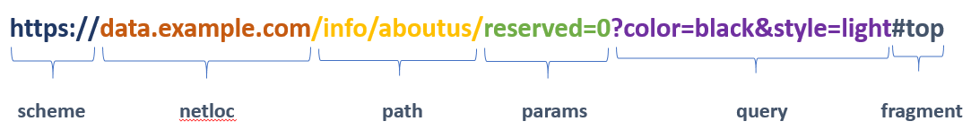

Domains were extracted from the netloc section. E.g. example.com.

Additional features were created to reflect the lexical characteristics of the entire url link and the parsed out registered domain, netloc, paths, parameters, queries and fragments[5].

|  |  |  |  |  |  |  |  |  |
| --- | --- | --- | --- | --- | --- | --- | --- | --- |
|  |  | **URL Section** | | | | | | |
| **Feature Type** | **Description** | **URL** | **Domain** | **NetLoc** | **Path** | **Param** | **Query** | **Frag** |
| **Length** | length | ü | ü | ü | ü | ü | ü | ü |
|  | avg section/token length | ü | ü | ü | ü |  |  |  |
|  | shortest path length |  |  |  | ü |  |  |  |
|  | longest path length |  |  |  | ü |  |  |  |
| **Composition** | list of all tokens | ü |  |  |  |  |  |  |
|  | number of sections |  | ü | ü | ü |  |  |  |
|  | number of letters | ü | ü | ü | ü | ü | ü | ü |
|  | number of numbers | ü | ü | ü | ü | ü | ü | ü |
|  | number of special characters | ü | ü | ü | ü | ü | ü | ü |
|  | percent of letters | ü | ü | ü | ü | ü | ü | ü |
|  | percent of numbers | ü | ü | ü | ü | ü | ü | ü |
|  | percent of special char | ü | ü | ü | ü | ü | ü | ü |
|  | percent of uppercase letters | ü |  |  | ü |  |  |  |
|  | percent of lowercase letters | ü |  |  | ü |  |  |  |
|  | location of last // | ü |  |  |  |  |  |  |
|  | location of last slashes as % | ü |  |  |  |  |  |  |
|  | number of @ signs | ü |  |  |  |  |  |  |
|  | number of underscores | ü |  |  |  |  |  |  |
|  | number of question marks | ü |  |  |  |  |  |  |
|  | number of %20 |  |  |  | ü |  |  |  |
|  | entropy | ü | ü | ü | ü | ü | ü | ü |
|  | number of masques | ü | ü | ü | ü | ü | ü | ü |
|  | character continuity rate | ü |  |  |  |  |  |  |
|  | is domain an ip address |  | ü |  |  |  |  |  |
|  | is domain in Alexa top 500 |  | ü |  |  |  |  |  |
|  | number of subdomains |  | ü |  |  |  |  |  |
|  | number of domain suffixes |  | ü |  |  |  |  |  |
|  | number of single character paths |  |  |  | ü |  |  |  |

Table 1: Feature Descriptions and Applicable URL Sections

Following is a brief description of several key features found in Feature Set 1.

*Entropy*: A Shannon entropy score is calculated, reflecting the string’s character distribution. Larger character distributions equate to a higher score.

*Character continuity rate*: Reflects the total of: length of the longest alphabetic string + length of the longest digit string + length of the longest special character string. This total is then divided by the length of the url.

*Number of masques*: A masque reflects a letter + digit + letter combination. This characteristic may reflect masquerading, an attempt to spoof a legitimate string with a deceptive replacement. E.g. goog1e.

*Percent of lowercase | Percent of upper case*: These two features reflect the percent of these characters compared to all alphabet characters in the referenced string.

*Is domain an ip address*: It’s not that uncommon for a url to have an IP address in lieu of a domain, but malicious links have a *much higher* occurrence.

*Is domain in Alexa top 500*: Each domain was checked against Alexa’s list of the current top 500 websites[6].

## Feature Set 1 - Final Data Wrangling Steps

Categorical features containing strings, such as url and other url elements, were dropped. Features with Boolean data types were changed to integer. One feature, avg_path_token_len, has missing values which will be replaced with 0s prior to machine learning.

The feature set now consists of ninety-six predictor variables and one target variable.

## Feature Creation – Feature Set 2

Urls were simply parsed into separate tokens. Each token consists of the same character type. For example [www.google.com](http://www.google.com) is parsed into: [www, ., google, ., com].

# Exploratory Data Analysis

Exploratory data analysis techniques were used to investigate, analyze and summarize characteristics of the url string and its components. This section covers key findings from feature set 1.

## Url String Analysis

Malicious URLS - Approximately 50% of the malicious urls in our dataset have an IP address in lieu of a domain name. This accounts for some of the notable differences in malicious url statistics, in comparison to the other categories. For example, on average, only 50% of the malicious url consists of letters, versus 71% and 73% for benign and phishing urls[7]. Malicious urls are, on average, shorter in length and have shorter token lengths.

Phishing URLs - The mean url length score is 89.1 in comparison to 57.4 for benign urls, and 44.9 for malicious urls. Thus, it's not surprising that phishing urls have the highest average number of tokens (20.8 versus 17.4 and 14.8) and longest average token length of 4.1 (versus 3.4 and 3.0). They also have the highest average entropy score and highest average masque count.

Chart 1: Number Representation in URLs

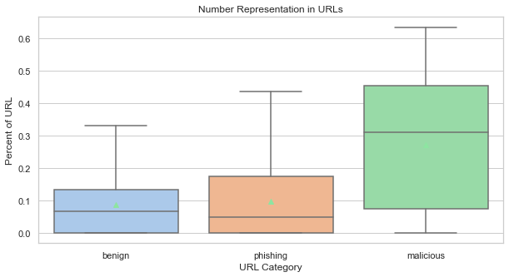

## Registered Domain Analysis

Malicious URLs - 54% of the records in this category have an IP address, not a registered domain name[8]. Malicious domains are on average shorter than phishing domains, but longer than benign domains. This category had the highest entropy score of 1.072, in comparison to .576 for benign and .778 for phishing domains[9].

Phishing URLS - Phishing domains are longer on average, with a longer token length.

Benign URLs - In comparison with the phishing and malicious domains, benign domains have shorter lengths overall, the lowest entropy score, a greater propensity to be on the Alexa Top 500 website list. They are the least likely url type to contain an IP address.

Chart 2: IP Addresses per Category

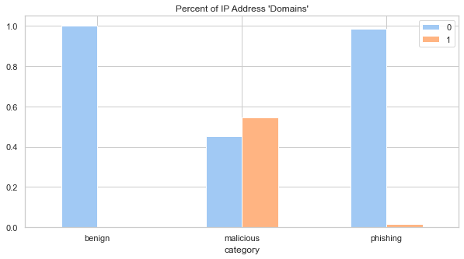

Chart 3: Domain Entropy Scores

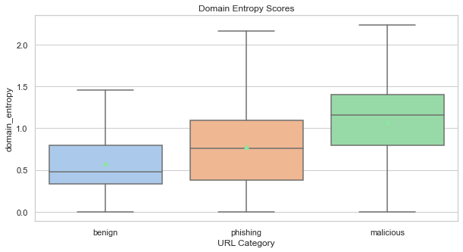

## Netloc String Analysis

Malicious URLS - For the malicious url category, this section is on average longer than benign urls and shorter than phishing urls (18.07 characters versus 13.55 for benign and 22.59 for phishing). The entropy score of 1.32 is similar to phishing's score of 1.34, but greater than benign urls' score of .85.

Phishing URLs - The phishing category trumps the others again with its high length scores. This category is also the most likely to have one or more subdomains.

Benign URLs - The benign netloc section has the lowest mean score for length (13.55 in comparison to phishing's 22.59 and malicious' 18.07). It has the lowest mean entropy and masque scores, lowest mean number of tokens, and shortest average token length. Subdomains are more common in benign urls than malicious urls.

## Path String Analysis

Malicious Category. In comparison to benign and phishing urls, urls in this category have shorter path sections on average (mean of 18.29 characters versus 30.26 for phishing and 36.46 for benign), and a smaller amount of path items (1.81 versus 2.47 for phishing and 2.26 for benign). They also have lower entropy scores (mean of .722 versus 1.33 and 1.52). In comparison to benign urls, malicious urls have a greater percentage of letters and special characters.

Phishing Category. In comparison to benign and malicious urls, these urls have a greater percentage of special characters (29.3% versus 16.2% and 23.2%) and masques (.468 versus .257 and .109). The path sections are a little shorter than benign url and have a greater propensity for single character paths.

Benign Category. These urls have the greatest tendency for numbers within path sections. Numbers comprise 14.3% of the path section, versus 8.7% and 7.6% for phishing and malware. This may be the reason for the highest average entropy score of all categories (1.529 versus 0.722 and 1.334). Its average path item length, 17.34, is much higher than the other categories which score 12.59 and 9.29.

## Inferential Statistics

For feature set 1, it is important to identify strong correlations between pairs of predictor variables and between predictor variables and category, our target variable.

Pairwise Correlation Analysis: We identified a considerable amount of highly correlated features. 73 pairs of features have correlation scores of 80% or higher.

Predictor v. Target Correlation Analysis: Numeric-based domain/netloc features are the most highly correlated with the target feature. The features with the top eight scores may be reflective of the fact that 50+% of the malicious urls in our dataset have numeric IP addresses instead of domain names. Since the domain and netloc features overlap, features may need to be tailored down before machine learning work.

# Machine Learning

## Model Evaluation Metrics

Metrics were gathered during machine learning and are included within our jupyter notebooks. A few are represented in this report.

First, a brief review of potential url classification outcomes:

|  |  |
| --- | --- |
| Classification Outcome | Description |
| True Positive (TP) | Model correctly predicts the positive class. URLs are correctly classified. E.g. A truly benign url is classified as benign. |
| False Positive (FP) | The model incorrectly predicts the positive class. URLs are incorrectly classified. E.g. An actual malicious url is misclassified as benign. |
| True Negative (TN) | The model correctly predicts the negative class. URLs are correctly classified. E.g. An actual malicious url is not classified as benign. |
| False Negative (FN) | The model incorrectly predicts the negative class. URLs are incorrectly classified. E.g. An actual malicious url is not classified as malicious. |

### Scores in our reporting:

***Log Loss -*** An important classification metric based on probabilities. Log Loss quantifies the accuracy of a classifier by penalizing false classifications. A good metric for comparing models, with lower **log loss**values meaning better predictions.

***Accuracy -*** Fraction of the total samples that were correctly classified as benign, phishing or malicious. Overall accuracy of the model.

***Classification Report***

Precision: The fraction of predictions as a positive class that were actually positive (TP/(TP + FP)).

Recall: The True Positive Rate: the fraction of all positive samples that were correctly predicted as positive by the classifier (TP/(TP + FN))

F1: A weighted averaged of the precision and recall scores, where an F1 score of 1 means it is 100% accurate. (2TP/(2TP + FP + FN))

Note: Our primary goal is to accurately classify malicious or phishing url links, attaining high true positive rates and low false negative rates. Therefore, recall scores for phishing and malicious urls are highly valuable.

***Confusion Matrix -*** Confusion matrices allow us to visualize TP / TN / FP / FN scores for each class. Confusion matrices for multi-class problems are not straight-forward. For example, in the matrix below[10], True positive classifications scores for malicious urls are obvious. Other measurements like TN, FP, FN can be derived with manual calculations. One can also rely on precision, recall and F1 scoring, which are based on these TP / TN / FP / FN prediction results.





Chart 1: Confusion Matrix Guide for Malicious URL Classification

## Feature Set 1 Machine Learning Model

Feature set 1 contains 96 predictor features created from lexical properties of the entire url string or its components, such as scheme, netloc, domain, path, fragment, parameters and queries.

### Baseline Models

Supervised learning algorithms capable of multi-class classification were explored. Prior to any pre-processing or normalization, several classifiers were trained on the feature set. The RandomForestClassifier achieved the best overall accuracy score and TP scores[11].



Table 1: Overview of Baseline Scores

### Random Forest Classifier

Based of the baseline scores, the Random Forest Classifier was selected as the algorithm to develop for this model.

Step 1. Normalization of features

I adopted MinMaxScaler for normalization, constraining the range of all numeric values between 0 and 1. The shape of the original distribution is maintained, so outliers still have influence.

Step 2. Parameter Tuning

I utilized GridSearchCV, which completes a thorough check for the parameter set that returns the best accuracy score. It does this by using all possible parameter combinations. I settled on these parameter settings:

1. Max depth of the tree = 30
2. Max features to consider when looking for the best split = 10
3. Min samples required to be at a leaf node = 1
4. Min samples split required to split an internal node = 2
5. Number of estimators (number of tress in the forest) = 800

Step 3. Validation of Scores

In the previous models, we split the dataset into 80/20 subsets, 80% used for training the model, 20% for testing. To ensure that our newly-tuned model will return similar results in real life applications (with new urls), a validation test is run.

StratifiedKFold was selected as the validation technique. It is a variation of KFold that preserves the percentage of samples for each class. Both the train and test partitions have equal portions of benign, phishing and malicious urls. Just like KFold, the validation test trains/tests on alternating sets of data. Accuracy scores are taken following each test.

The mean accuracy score following our StratifiedKFold cross-validation with 5 splits is 93.14, with a standard deviation of .0035. The accuary scores and standard deviation prove that our model is stable and should perform well on unseen data.

Step 4. Prediction and Final Scores

Our final step is to split our dataset 80/20, fit and predict on the model, evaluate our scores and feature importance. As indicated in Table 2, our final model scores are not higher across the board, but close to initial baseline and other models. [12]

|  |  |  |  |  |  |
| --- | --- | --- | --- | --- | --- |
| **RandomForestClassifier** |  |  | Benign | Phishing | Malicious |
| **Accuracy** | **Log Loss** | **Confusion Matrix – TP scores** | | |
| **Baseline Scores** | 0.928 | 0.222 | 0.974 | 0.903 | 0.906 |
| **Baseline w/ MinMaxScaler** | 0.932 | 0.205 | 0.971 | 0.907 | 0.919 |
| **Predict after Tuning** | 0.931 |  | 0.973 | 0.905 | 0.916 |

Table 2: Random Forest Classifier Score Review

Our final Random Forest Classification report shows some variability in our model’s classification accuracy for benign versus phishing and malicious urls.

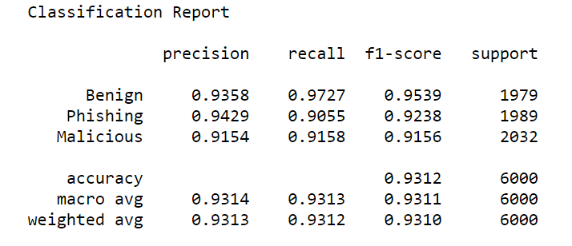

Domain and netloc features predominate in feature importance scores for our Random Forest Classifier[13].



Table 3: Feature Importance Scores

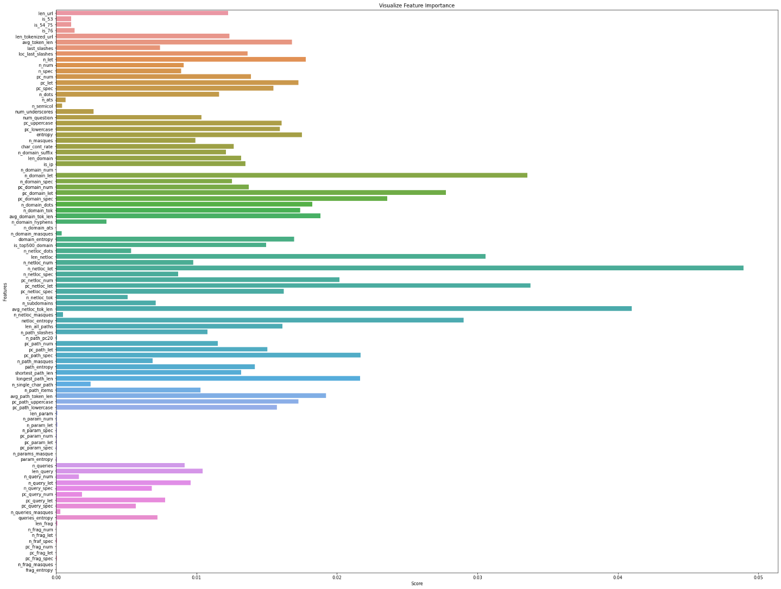

Chart 2: Feature Importance Scores

In order to improve the efficiency of our model and remove some redundancy in our dataset (as indicated with the feature importance scores), I decided to make alterations to the dataset. Details follow.

### Random Forest Classifier with Reduced Dataset

As stated previously, netloc and domain features dominated the top 20 features of importance in our Random Forest Classifier. I decided to train models with a reduced feature set. Using the feature importance list and the pairwise correlation data, I carefully selected a set of twenty-two predictor variables[14], that covered the essential url characteristics. I then completed the same machine learning workflow steps, as with the full dataset.

|  |  |
| --- | --- |
| **Selected Predictor Features** | |
| pc_num | len_netloc |
| pc_uppercase | n_netloc_tok |
| pc_spec | pc_netloc_spec |
| entropy | pc_netloc_num |
| len_domain | netloc_entropy |
| is_top500_domain | path_entropy |
| pc_domain_spec | avg_path_token_len |
| pc_domain_num | longest_path_len |
| n_domain_suffix | pc_path_uppercase |
| n_domain_tok | len_all_paths |
| domain_entropy | pc_path_num |

Table 4: Reduced Feature Set

As the following results show[15], we did not achieve higher scores for baseline models and the final Random Forest Classifier model[16]. Multicollinearity does not negatively affect prediction accuracy.

|  |  |  |  |  |  |
| --- | --- | --- | --- | --- | --- |
|  |  |  | Benign | Phishing | Malicious |
|  | **Accuracy** | **Log Loss** | **Confusion Matrix - TP Scores** | | |
| **KneighborsClassifier** | 81.813 | 1.874 | 0.88 | 0.79 | 0.78 |
| **DecisionTreeClassifier** | 87.453 | 4.333 | 0.91 | 0.87 | 0.84 |
| **RandomForestClassifier** | 92.147 | 0.247 | 0.97 | 0.89 | 0.91 |
| **AdaBoostClassifer** | 82.080 | 1.016 | 0.89 | 0.78 | 0.79 |
| **GradientBoostingClassifier** | 87.586 | 0.342 | 0.94 | 0.84 | 0.85 |
| **XGBClassifier** | 86.760 | 0.367 | 0.94 | 0.83 | 0.84 |

Table 5: Baseline Classifier Scores with Reduced Feature Set

|  |  |  |  |  |  |
| --- | --- | --- | --- | --- | --- |
| **RandomForestClassifier** |  |  | Benign | Phishing | Malicious |
| **Accuracy** | **Log Loss** | **Confusion Matrix – TP Scores** | | |
| **Baseline** | 0.920 | 0.245 | 0.964 | 0.884 | 0.911 |
| **Baseline w/ MinMaxScaler** | 0.928 | 0.222 | 0.966 | 0.897 | 0.920 |
| **Predict** | 0.922 |  | 0.967 | 0.885 | 0.914 |

Table 6: Random Forest Classifier Scores, Reduced Feature Set

The tables below compare feature importance scores for both the full and reduced feature sets[17]. Multicollinearity may affect the ability to interpret the parameters learned by our models. We cannot say that the features with the largest weights are the most important when features are highly correlated with each other.

The 96 predictor feature set’s top scorers stem from the domain/netloc section of the url. After reducing the feature set to 22 predictors, we still have a high proportion of domain/netloc features, but new features appear and features like entropy and the percent of special characters move up significantly in the importance list.



Table 7: Feature Importance Comparison

## Feature Set 2 Machine Learning Model

For this approach, natural language processing (NLP) techniques were used to train and test our models.

### Feature Creation

For NLP we require a corpus, a collection of texts. For this url classification project, the corpus consists of url tokens. We start with just a dataframe of 30,000 url strings, each classified with a benign, phishing or malicious label. With the help of the **nltk.tokenize.WordPunctTokenizer()** method, tokens are extracted from each url string and stored in a new ‘tokenized_url’ feature. For example, applying the WordPunctTokenizer[18] method on <https://www.google.com> returns the following tokens: https, ://, www, ., google, ., com.

### Vectorization & Transformation

Our url tokens need to be transformed into vector representations since machine learning algorithms require a numeric feature set. Our url token lists are of varying length, but after the numeric transformation step (vectorization), our vector representations will be of uniform length.

There are several vectorization methods and tools to perform the transformation. For this project we leverage TF-IDF and utilize scikit-learn’s TfidVectorizer to do the conversion and return a matrix of TF-IDF features.

#### TF-IDF

TF-IDF stands for Term-Frequency-Inverse Document Frequency. With this approach each url token is assigned a number that is proportional to its frequency in the url string and inversely proportional to the number of url strings in which it occurs.

Other encoding approaches exist, like bag-of-words representations. But they only take individual documents (urls, in our case) into consideration, and not the context of the entire corpus.

Formulas:

N - number of urls we have in our dataset

d – a given url from the dataset

D - the collection of all urls

W - a given token from a url

f(w,d) - frequency of word w in document d

Term Frequency (TF) Formula

**tf(w,d) = log(1+f(w,d))**

Inverse Document Frequency (IDF) Formula

**idf(w, D) = log(N/f(w,D))**

TF-IDF formula

**Tfidf(w,d,D) = tf(w,d)*idf(w,D)**

Following TF-IDF scoring of our url records, we are left with a matrix of td-idf scores with one row per url, and as many columns as there are different tokens in the entire corpus.

#### Scikit_learn TfidVectorizer

TF-IDF scores may be calculated manually, but our models utilize Scikit-Learn’s TfidVectorizer transformer, which uses an estimator to count the occurrences of tokens (TF), followed by TfidTransformer which normalizes these counts by the inverse document frequency(IDF). The vectorizer returns a sparse matrix representation in the form of ((doc, term), tfidf score) where each key is a document and term pair.

### Baseline Models

Our matrix is finally split into train and test subsets and multiple algorithms are fitted to gather baseline accuracy scores and confusion matrices. The LinearSVC model achieved the best overall accuracy score and true-positive rates (with the exception of TP scores for malicious urls)[19].



Table 8: Baseline Classifier Scores

Since these baseline scores are higher than our model using a 96 predictor feature set, we continue to develop the top 3 classifiers - LinearSVC, Random Forest Classifier and Logistic Regression.

### Random Forest Classifier – LinearSVC – Logistic Regression

For each of these classifiers, we followed these steps:

Step 1. Normalization of features

No further steps required.

Step 2. Parameter Tuning

We utilized GridSearchCV to test all parameter combinations and provide the best parameters

The following parameters[20] were returned:



Table 9: Best Parameters per Classifier

Step 3. Validation of Scores

StratifiedKFold was selected as the validation technique, to preserve the percentage of samples for each class. For each algorithm, our accuracy scores remained consistent across all folds. The mean accuracy scores and standard deviation following StratifiedKFold cross-validation with 5 splits[21]:

|  |  |  |
| --- | --- | --- |
|  | Mean Accuracy | Standard Deviation |
| LinearSVC | 96.31 | 0.0015 |
| Logistic Regression | 96.21 | 0.0021 |
| Random Forest Classifier | 96.21 | 0.0021 |

Table 10: StratifiedKFold Results

Step 4. Prediction and Final Scores

Our final step was to split our dataset 80/20, fit and predict on each model and evaluate our scores.

Results[22]:

* LinearSVC and Random Forest Classifier tie on the overall accuracy score
* LinearSVC has the highest True Positive detection rate for benign and phishing urls
* Random Forest Classifier has the best True Positive scoring for malicious urls



Table 11: Classifier Final Results

Our models’ Classification Reports[23] cover the following:

|  |  |  |
| --- | --- | --- |
| Precision | TP / (TP + FP) | The fraction of predictions as a positive class that were actually positive. |
| Recall | TP / (TP + FP) | The fraction of all positive samples that were correctly predicted as positive by the classifier. |
| F1 | 2TP / (2TP + FP + FN) | A combined measure of both precision and recall. |

Best Recall Scores:

The Random Forest Classifier model will accurately classify 95.55% of actual malicious urls as malicious.

The LinearSVC model will accurately classify 98.35% of actual benign urls as benign, and 96.49% of actual phishing urls as phishing.

|  |  |  |  |
| --- | --- | --- | --- |
|  |  |  |  |
|  | **LinearSVC** | | |
| precision | recall | f1-score |
| benign | 0.9825 | 0.9835 | 0.9830 |
| phishing | 0.9286 | 0.9649 | 0.9464 |
| malicious | 0.9781 | 0.9391 | 0.9582 |
|  |  |  |  |
|  |  |  |  |
|  |  |  |  |
|  | **Random Forest** | | |
| precision | recall | f1-score |
| benign | 0.9839 | 0.9765 | 0.9802 |
| phishing | 0.9371 | 0.9554 | 0.9462 |
| malicious | 0.9671 | 0.9555 | 0.9613 |
|  |  |  |  |
|  |  |  |  |
|  |  |  |  |
|  | **Logistic Regression** | | |
| precision | recall | f1-score |
| benign | 0.9659 | 0.9735 | 0.9697 |
| phishing | 0.9136 | 0.9479 | 0.9304 |
| malicious | 0.9691 | 0.9251 | 0.9466 |

Table 18: Classification Reports for All Models

### Stacking

As a final step to potentially improve on the machine learning model performance utilizing TF-IDF scores, stacking was completed. Stacking is an ensemble learning technique which combines multiple classification models with a meta-classifier. The base-level models are trained on a complete training set. The meta-classifier is trained on the features that are outputs of the base-level model.

Our base models are heterogenous: Logistic Regression, Random Forest Classifier and LinearSV. Logistic Regression is used as the meta-classifier.

As per the results, our overall accuracy score and recall score for phishing improve.

|  |  |  |  |  |  |
| --- | --- | --- | --- | --- | --- |
|  |  |  | **Benign** | **Phishing** | **Malicious** |
| **Stacking** | **Features** | **Accuracy** | **Recall Scores** | | |
| **Logistic Regression meta-classifier** | Base Predictions | 0.9633 | 0.9805 | 0.9699 | 0.9396 |

# Machine Learning Summary

While both features sets produced overall accuracy scores of 90% or higher, the feature set leveraging natural language processing achieved the best overall scores[24]. The stacked model returned the highest overall accuracy score of 96.33.

Focusing on recall scores, models trained on the TF-IDF scores returned superior results. The Random Forest Classifier model returned the highest score for classifying positive malicious urls, the LinearSVC model returned the highest recall scores for classifying benign urls, and the stacked model returned the highest recall score for phishing urls.



Table 19: Overview of Models: Accuracy & Recall Scores

It is important to note the lightweight nature of each model created for this project. After accumulating the necessary phishing, malicious and benign url strings, feature creation for both feature sets relied solely on url strings and were built ‘in-house’. No further data was necessary from third party sources. Achieving high scores with models built solely with lexical or TF-IDF-based features is tremendous.

# Using a Model in a Production Environment

The goal of this project was to build a url classification model to assist in the investigation of events involving a url, and/or defend against (or prevent activity) related to phishing and malicious urls.

The selection of a model is dependent on how it’s leveraged in any environment. For example, for investigation of a past event, a model would classify a url that had already passed a user or organization’s security infrastructure. In this case, a model with high recall scores in classifying phishing or malicious urls would be selected. In an organization was limited to just one model, I would select the Random Forest Classifier trained on the TF-IDF scores. The model could be leveraged in an automated security operations workflow that analyzes urls links in emails or url links involved in suspicious web traffic.

# Next Steps

Here is a list of potential next steps:

* While models relying on a features set built entirely from url lexical properties did not perform as well as those relying on TF-IDF scores, they show promise. Additional features can be explored to supplement the feature set, to improve model performance.
* For TF-IDF based models leveraging stacking, additional base classifiers may be explored, such as GaussianNB and Decision Tree, to potentially improve overall scores.
* Separate models may be built to classify individual url types. Separate models focusing on one url type (e.g. malicious urls) may achieve higher accuracy, precision and recall scores.

1. <http://phishtank.org/developer_info.php>
2. <https://urlhaus.abuse.ch>
3. <https://www.alexa.com/topsites>
4. <https://www.virustotal.com>
5. See Table 1 for feature descriptions
6. <https://www.alexa.com/topsites>
7. See Chart 1: Number Representation in URLs
8. Chart 2: IP Addresses per Category
9. Chart 3: Domain Entropy Scores
10. Chart 1: Confusion Matrix Guide for Malicious URL Classification
11. Table 1: Overview of Baseline Scores
12. Table 2: Random Forest Classifier Score Review
13. Table 3: Feature Importance Scores; Chart 2: Feature Importance Scores
14. Table 4: Reduced Feature Set
15. Table 5: Baseline Classifier Scores with Reduced Feature Set
16. Table 6: Random Forest Classifier scores
17. Table 7: Feature Importance Comparison
18. https://www.nltk.org/api/nltk.tokenize.html#nltk.tokenize.regexp.WordPunctTokenizer
19. Table 8: Baseline Classifier Scores
20. Table 9: Classifier Best Parameters
21. Table 10: StratifiedKFold Results
22. Table 11: Classifier Final Results
23. Table 18: Classification Reports for All Models
24. Table 19: Overview of Models: Accuracy & Recall Scores